IP and Brexit – What Happened and What’s Next?

EU/UK IP Brexit Workshop with Cleveland Intellectual Property Law Association (CIPLA) – Thursday March 11, 2021 conducted by Shane Smyth, FRKelly, Dublin, Ireland.

Now that the UK has left the EU – with a Withdrawal Agreement rather than the dreaded No-Deal scenario – the following changes have taken place. There are still a few areas where the new relationship has not yet been fleshed out (for example in parallel imports) but they are in the minority.

EUTM Existing Registrations

Any EUTMs which were registered as of 1 January 2021 have been automatically cloned into UK national registrations, with a new registration number created by adding 009 in front of the EUTM number, with additional zeros as required to make the section after the 009 have 8 digits. For example, the EUTM No. 7227051 for the former FRKELLY logo has now been cloned into a UK registration No. UK00907227051,whereas EUTM No.18164942 for the current FRKELLY logo has been cloned into a UK registration No. UK00918164942.



There has been no official fee charged for the cloning of the right, but the cloned UK registration will need to be renewed separately from the EUTM from 1 January 2021 onwards, with same renewal date applying to both registrations. If you don’t want a UK registration for that mark, you can opt out or simply let the UK registration lapse on next renewal.

We are providing a special rate for 2021 to clients for renewing cloned UK registrations, in recognition of the additional costs which will be borne by clients who consider it important to retain that UK protection and which might not have been in their long-term budgets. Also, the UKIPO will not charge additional late renewal fees for any cloned registrations with due dates falling in the six months after 1 January 2021.

For any EUTM registrations which were due for renewal in the 6 months before 1 January 2021 and which were not renewed on time, the UKIPO created a cloned UK registration as the EUTMs were still within their late renewal period. If the EUTM is duly renewed by the late renewal date, the UK cloned registration will also be considered as renewed without any additional fees. The important point is the original renewal due date of the EUTM: if it was before 1 January 2021 then the renewal also has effect in the UK; if it was after 1 January then the UK clone will have to be renewed separately.

EUTM Pending Applications

Pending applications for EUTMs which were pending as of 1 January 2021, including opposed applications, have the option of being refiled as UK national applications within a 9 month deadline from that day, keeping the EU filing date as the effective date for the UK.

This means that all of these marks have a deadline of 30 September 2021 to be refiled as UK applications. The usual national application fees apply for a UK trade mark, but we are providing a special rate to clients for these re-filings.

If the EUTMs are not refiled in the UK, the marks will not be protected in the UK. The UKIPO will not send any notifications of the option to refile in the UK to trade mark owners. Ideally brand owners might want to commence their re-filings in good time before 30 September 2021, to avoid the UK applications being stuck in a backlog for examination, as a large number of applications are expected to be filed on that date.

International Trade Mark Registrations designating the EU

Any granted EU designations were cloned into UK national registrations on 1 January 2021 and are no longer a part of the International Registrations. The UKIPO allocated these UK clones a new registration number created by adding 008 in front of the International Registration number, with sufficient zeros to create 8 digits after the 008. For example, an International Registration designating the EUTM system with number 123456 will now have a UK national registration clone no. UK00800123456.

The renewal date will be calculated from the effective date of the EU designation. We will be providing a special rate for 2021 to clients for renewing these cloned UK registrations, in recognition of the additional costs which will be borne by clients who consider it important to retain that UK protection and which might not have been in their long-term budgets.

Any EU designations which were pending as at 1 January 2021 will need to be refiled as UK national applications by 30 September 2021, with the usual national application fees for a UK trade mark. We are providing a special rate to clients for these re-filings. The UK national application will not be a part of the International Registration.
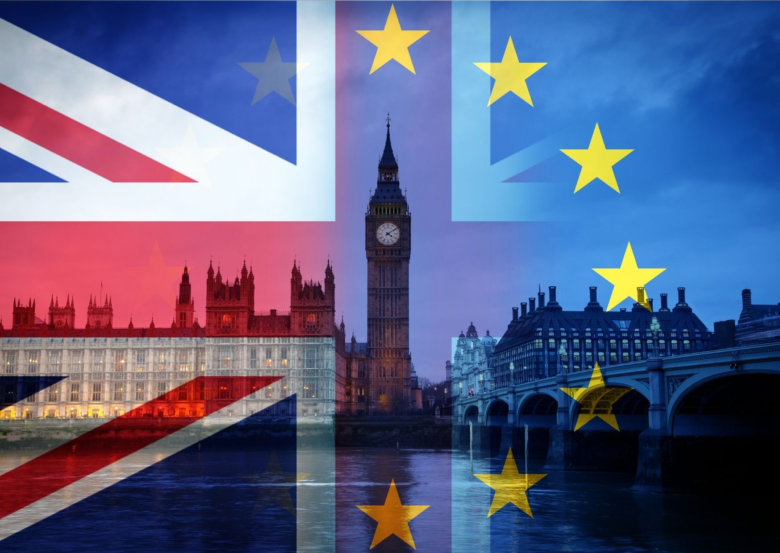

Proof of Trade Mark Use

For a cloned UK registration, use in the EU before 1 January 2021 will be accepted as if it was use in the UK for defending revocation actions or proving use of the UK registration in opposition proceedings.

For an EUTM, use in the UK before 1 January 2021 will be accepted as being use in the EU for defending revocation actions or proving use of an EUTM in opposition proceedings.

EU Registered Designs - Registered Community Designs (RCDs)

All registered and published EU registered designs now have comparable UK designs, which are recorded on the UK register. These are treated as if they had been registered under UK law. The holder of an existing EU registered design is automatically provided with an equivalent UK registered design right. The new UK registered design will retain the registration and application dates of the corresponding EU trade mark and will also inherit any priority dates. As independent UK design rights, the UK rights may be assigned, licensed, and renewed separately from the original EU registered design.

Pending EU Registered Design Applications

If your client owns a pending EU registered design application as of January 1, 2021, your client will be able to apply to register an equivalent UK design in the 9 month period until September 30, 2021, and retain the earlier EU filing date. In order to re-file, the UK application must pertain to the same design as that covered by the pending EU application. The new applications will be treated as UK registered design applications, and will be examined under UK law. Additional UK filing fees will be payable.

Pending Cancellation Actions

Where an EUTM (or RCD) registration was subject to ongoing cancellation proceedings on 1 January 2021, and that registration is subsequently cancelled, the outcome of the cancellation proceedings will be applied to the corresponding UK clone. The only exception is where the basis for cancellation would not apply in the UK (for example if the cancellation action was based solely on a German registration).

Pending EU actions based on UK rights

The EUIPO has stated that any EUTM oppositions or cancellation actions pending on 1 January 2021 which are grounded on UK rights will no longer be considered valid as regards those grounds. It remains to be seen how this will be interpreted or if it will be challenged.

Patents

European Patents are granted by the EPO under the European Patent Convention, which is an autonomous legal system to the EU and so the grant procedure for European Patents remains unchanged. The grant of UK Patents remains the responsibility of the United Kingdom Intellectual Property Office, meaning the grant of UK Patents also remains unchanged. Any granted UK Patents or any European Patents validated in the UK continue to take effect in the UK as before.

Customs Notifications

As of 1 January 2021, any EU applications for action (customs notifications) can no longer cover the UK, although the UK has said it will continue to observe any EU applications filed through the UK until the next renewal date as if they were national UK applications. Henceforth, any rights holders who wish to have UK customs notification protection will have to file a separate UK application for action through a new online procedure set up for that purpose.

The substantive provisions have been retained unchanged for the moment but the administrative procedures will be somewhat different. For example, the UK authorities will reject any applications filed through the new UK procedure which cite the EUTM details, as they are no longer effective in the UK, and the details of the UK cloned right must be used.

Any rights holders who wish to have EU protection will have to file their EU applications through an EU member state (i.e. not through the UK).

EUIPO and UKIPO representation

From 1 January 2021, the rights of UK-based attorneys to represent clients before the EUIPO ceased and they will be automatically removed from all EUTM files and proceedings save for a small number of pending files. Similarly the rights of EU-based attorneys to represent clients before the UKIPO ceased on 1 January, although there is a grace period of 3 years during which EU attorneys can remain on record for the UK clones.

FRKelly has offices in the EU (Dublin and Cork, Ireland) and the UK (Belfast, Northern Ireland) and is ideally placed to continue to represent clients seamlessly across their entire EU and UK portfolios.

What you need to do now

Brexit has changed your clients’ EU intellectual property rights, and I have not covered all aspects of the effect of Brexit on IP rights here. However there are a few matters that your clients will need to consider now:

- Be aware of new comparable UK rights and ensure provisions to renew the rights separately from EU rights.
- Remember to apply to register any pending EU unitary rights in the UK by 30 September 2021 for trademarks and designs.
- Consider that they will now have to apply to cover the EU and the UK separately in any new filing strategy.
- Make sure they have an address for service in the EU/EEA for EU rights and an address for service in the UK, Gibraltar or the Channel Islands for any new UK rights.

Shane Smyth
FRKelly, Dublin, Ireland
s.smyth@frkelly.com
00353 1 2314806

